Loaded and Smashed Baked Potatoes
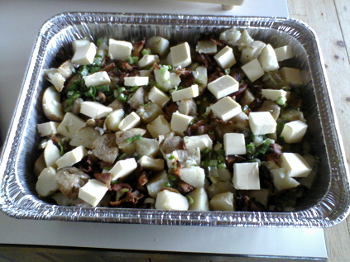
A full aluminum baking pan feeds approx. 8-10 persons.
Everyone loves a great baked potato. This variation feeds a crowd without all the mess.
- 5 lbs of Idaho/Russet Potatoes cleaned and halved
- 1 bunch of green onions – chopped finely
- .25 of a bunch of chives – chopped finely
- 1 Lb Smoked Bacon – fried and chopped
- 1 Lb Unsalted Butter – cubed
- 8 oz. of 5% Cream
- 1 qu. Sour Cream

- Clean potatoes and halve, then bake at 400 for 45 min.
- Fry 1lb of bacon to chewy crunchy texture, and chop
- Let potatoes rest for 30 minutes, then smash with a mashers…leaving whole chunks
- Add, green onion, chive, bacon, and cubed butter evenly over the smashed potatoes
- Top with the cream all around
- Bake in oven at 350 degrees for 20 minutes
- Serve with Sour Cream

